On the Windows box (e.g. msf1vpom04d), logon as the service account (e.g TJXASVC-POEM-DEV) and follow the steps:

To enable CredSSP authentication and to configure WINRM for https, the following steps had to be done.

1. Enable-WSManCredSSP -role server –Force
2. Check if there is a valid SUBCA certificate on the computer. If not, manually request for one, as shown in screenshot.

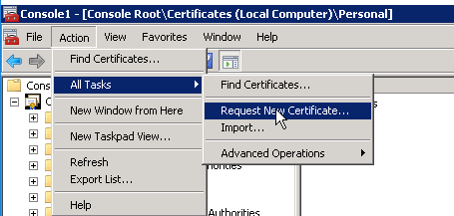

1. Need to know hostname and certificate thumbprint of the valid certificate.
2. winrm create --% winrm/config/Listener?Address=*+Transport=HTTPS @{Hostname="msf1vpom04d.tjx.com";CertificateThumbprint="1d 5c c8 40 f0 ea b5 60 be 34 19 25 40 98 7c 39 e8 16 4b a2"}

To get Certificate thumbprint,

go to MMC -> File (add or remove snap-ins) -> -> Certificates -> Personal  -> **Certificates** → double click certificate → details tab to get the thumbprint

